User manual

1. General information
2. On the navigation bar, the user can acquire the basic information of movie club in Carey.



1. On the bottom of the website, the user can obtain the movie hours of recent movies and subscribe the e-mail address to receive the up to date information of our event.

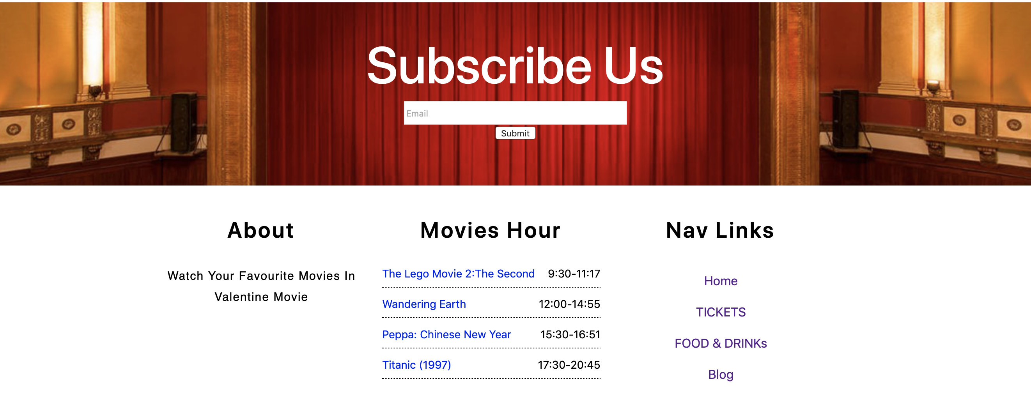

1. Movie list

In this section, the user can read about the outline of the movie and acquire the time and location of the specific movie.

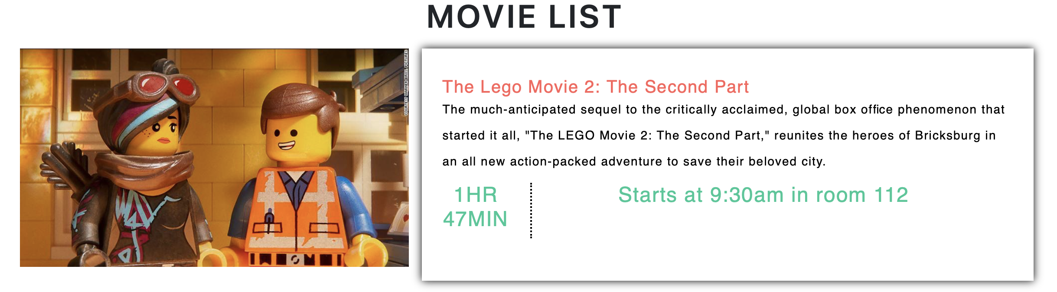

1. Create an account and log in

The user can create an account by submitting his personal information. Additionally, you can click on the refresh button to clear all the information you entered.

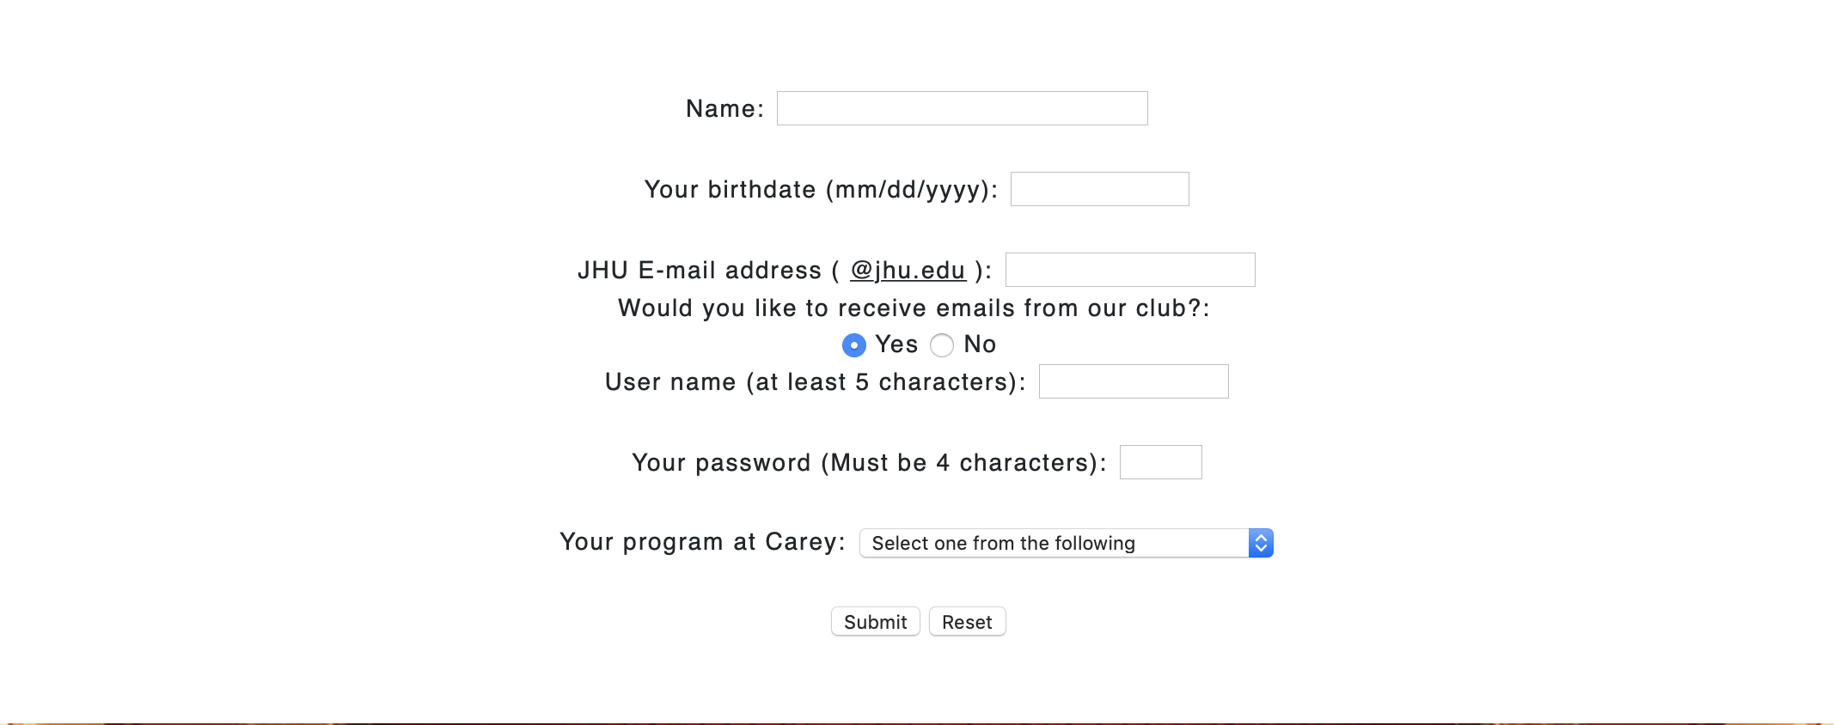

After creating the account, the user can log into the website at any time with his username and password.

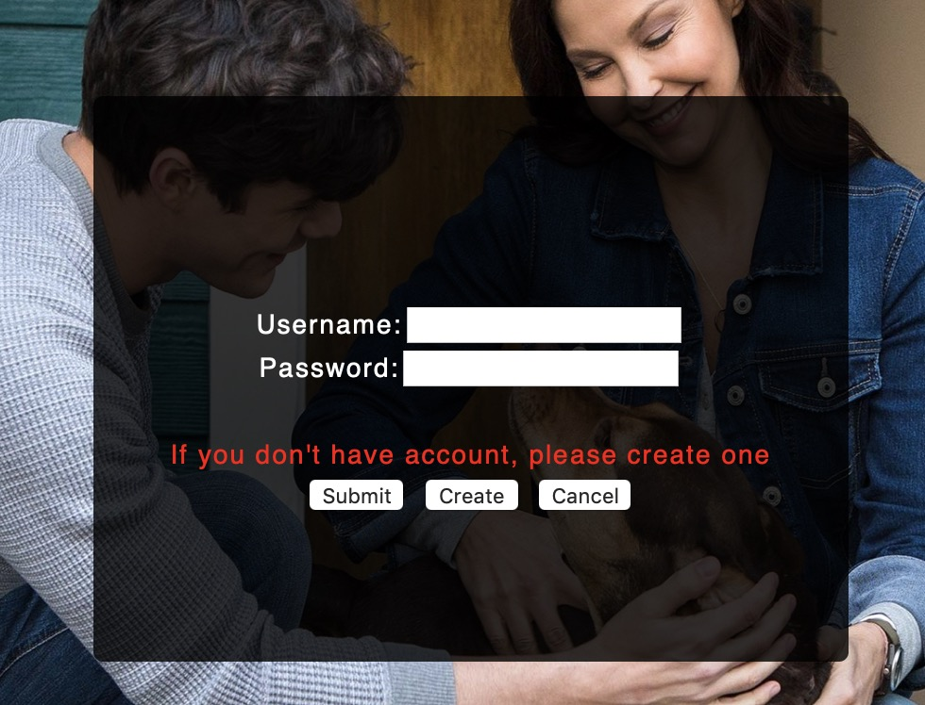

1. Ticket purchasing

After deciding which movie to watch, the user can click the “Tickets” button on the navigation bar to purchase the tickets.



In the tickets purchasing section, the user can choose which movie they want to watch. After that, the user can choose how many tickets they want to purchase meanwhile the website can calculate the total price of tickets the user should pay. Before the check out, the user should enter his name and phone number on the checkout site.

If the remaining tickets are out of stock, the user cannot purchase tickets for the movie.

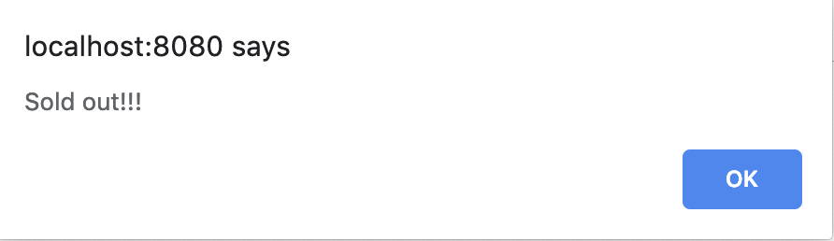

There are several targeted users we want to include in the website--- students, faculty staff, and their families. They can enjoy the better discount on the tickets price. Of course, our website encourages more users to engage in.

As for the editor of our website, we can easily to add new movies into the movie list without change the whole structure of website as well as the checkout page.

User interaction

1. Subscribing the e-mail

User can subscribe their e-mail to the website to receive the updated information of the movie club. After subscribing, the confirmation e-mail will send to the user to authenticate the e-mail address.

1. User profile management

When user check out, the personal information will be transferred to the database of the website. After checking out, the confirmation message will send to the user’s phone.

1. Club service

Our club services provide the phone number on the navigation bar, where can be reached all the day.

1. Food & Drinks (under development)

User can purchase the food and drinks online to enjoy when they are watching the movie.